

**Industrial Internship Report on**

**“Console-Based Expense Tracker Application”**

**Prepared by**

**[Anant Kumar]**

|  |
| --- |
| *Executive Summary* |
| This report provides details of the Industrial Internship provided by upskill Campus and The IoT Academy in collaboration with Industrial Partner Uni Converge Technologies Pvt Ltd (UCT).  This internship was focused on a project/problem statement provided by UCT. We had to finish the project including the report in 6 weeks’ time.  My project was (Tell about ur Project)  This internship gave me a very good opportunity to get exposure to Industrial problems and design/implement solution for that. It was an overall great experience to have this internship. |

**TABLE OF CONTENTS**

1 Preface 3

2 Introduction 4

2.1 About UniConverge Technologies Pvt Ltd 4

2.2 About upskill Campus 8

2.3 Objective 9

2.4 Reference 9

2.5 Glossary 10

3 Problem Statement 11

4 Existing and Proposed solution 12

5 Proposed Design/ Model 13

5.1 High Level Diagram (if applicable) 13

5.2 Low Level Diagram (if applicable) 13

5.3 Interfaces (if applicable) 13

6 Performance Test 14

6.1 Test Plan/ Test Cases 14

6.2 Test Procedure 14

6.3 Performance Outcome 14

7 My learnings 15

8 Future work scope 16

# Preface

Summary of the whole 6 weeks’ work.

About need of relevant Internship in career development.

Brief about Your project/problem statement.

Opportunity given by USC/UCT.

How Program was planned

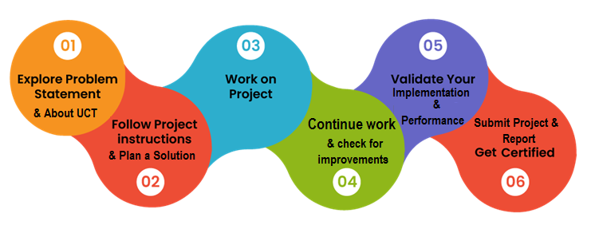

Your Learnings and overall experience.

Thank to all (with names), who have helped you directly or indirectly.

Your message to your juniors and peers.

# Introduction

## About UniConverge Technologies Pvt Ltd

A company established in 2013 and working in Digital Transformation domain and providing Industrial solutions with prime focus on sustainability and RoI.

For developing its products and solutions it is leveraging various**Cutting Edge Technologies e.g. Internet of Things (IoT), Cyber Security, Cloud computing (AWS, Azure), Machine Learning, Communication Technologies (4G/5G/LoRaWAN), Java Full Stack, Python, Front end**etc.

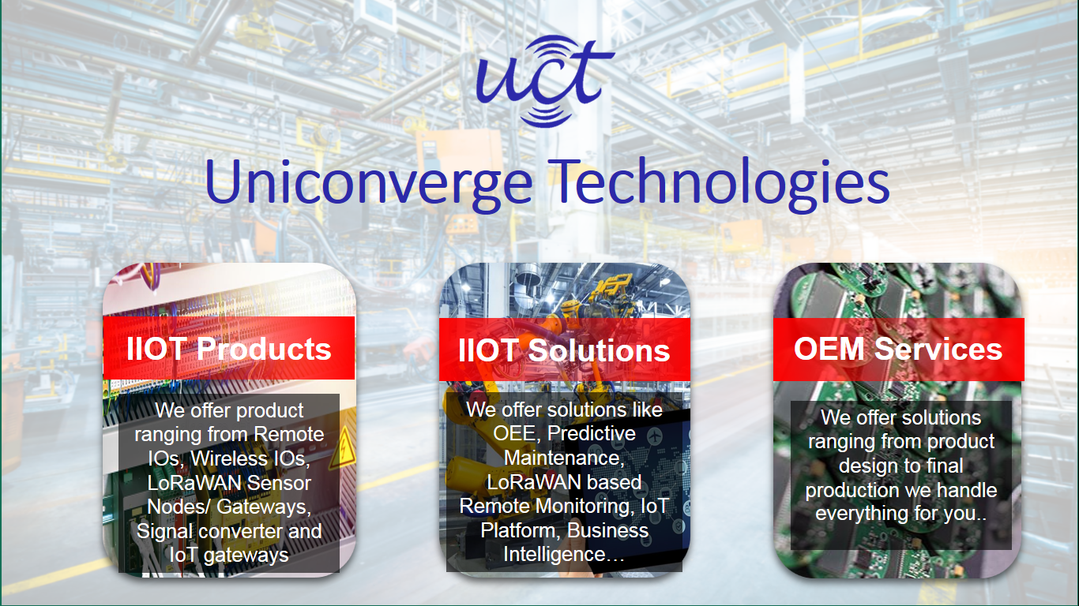

1. UCT IoT Platform **(****)**

**UCT Insight** is an IOT platform designed for quick deployment of IOT applications on the same time providing valuable “insight” for your process/business. It has been built in Java for backend and ReactJS for Front end. It has support for MySQL and various NoSql Databases.

* It enables device connectivity via industry standard IoT protocols - MQTT, CoAP, HTTP, Modbus TCP, OPC UA
* It supports both cloud and on-premises deployments.

It has features to  
• Build Your own dashboard  
• Analytics and Reporting  
• Alert and Notification  
• Integration with third party application(Power BI, SAP, ERP)  
• Rule Engine

 

1. **Smart Factory Platform (****)**

Factory watch is a platform for smart factory needs.

It provides Users/ Factory

* with a scalable solution for their Production and asset monitoring
* OEE and predictive maintenance solution scaling up to digital twin for your assets.
* to unleased the true potential of the data that their machines are generating and helps to identify the KPIs and also improve them.
* A modular architecture that allows users to choose the service that they what to start and then can scale to more complex solutions as per their demands.

Its unique SaaS model helps users to save time, cost and money.

 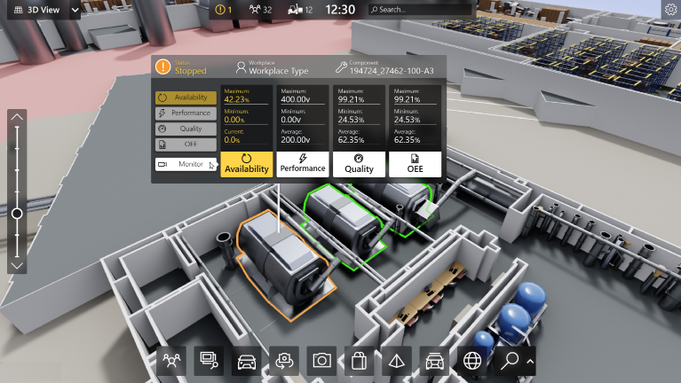

1. 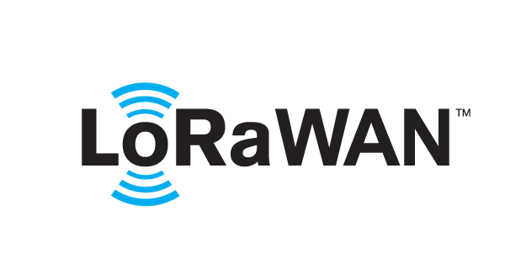 based Solution

UCT is one of the early adopters of LoRAWAN teschnology and providing solution in Agritech, Smart cities, Industrial Monitoring, Smart Street Light, Smart Water/ Gas/ Electricity metering solutions etc.

1. Predictive Maintenance

UCT is providing Industrial Machine health monitoring and Predictive maintenance solution leveraging Embedded system, Industrial IoT and Machine Learning Technologies by finding Remaining useful life time of various Machines used in production process.



## About upskill Campus (USC)

upskill Campus along with The IoT Academy and in association with Uniconverge technologies has facilitated the smooth execution of the complete internship process.

USC is a career development platform that delivers **personalized executive coaching** in a more affordable, scalable and measurable way.



Seeing need of upskilling in self paced manner along-with additional support services e.g. Internship, projects, interaction with Industry experts, Career growth Services

<https://www.upskillcampus.com/>

upSkill Campus aiming to upskill 1 million learners in next 5 year

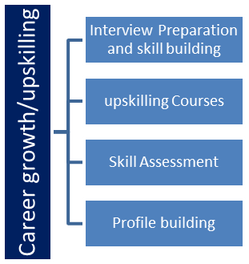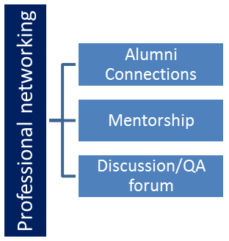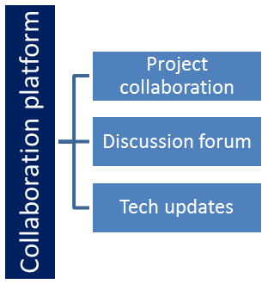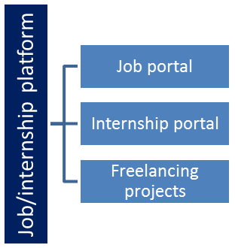

## The IoT Academy

The IoT academy is EdTech Division of UCT that is running long executive certification programs in collaboration with EICT Academy, IITK, IITR and IITG in multiple domains.

## Objectives of this Internship program

The objective for this internship program was to

 ☛ get practical experience of working in the industry.

 ☛ to solve real world problems.

 ☛ to have improved job prospects.

 ☛ to have Improved understanding of our field and its applications.

 ☛ to have Personal growth like better communication and problem solving.

## Reference

* [1] Y. Shao et al.

### Object tracking and localisation in Bayesian reasoning architecture

* I.D. Reid et al.

### Active tracking of foveating feature cluster using affine structure

### Int'l Journal Computer Vision

(1996)

* J.C. Clarke et al.

### Detecting and tracking linear features efficiently

# Problem Statement

# Create a Console-based Expense Tracker application that allows users to manage their personal expenses. The application should provide functionalities to record and track expenses, view spending summaries, and manage categories for better organization.

# Existing and Proposed solution

There are many models which are already available or build on expense tracking application, they have many functionalities but limited. Whether my project is based on console expense tracking ang have many functionalities which are not available in my previous models.

My project aims is to develop a Java application that enables users to manage their personal expenses efficiently. The application will offer functionalities for recording, tracking, filtering, modifying, and deleting expenses, as well as generating reports and providing a user-friendly interface.

1. Requirement Analysis:

- Reviewed and finalized the project requirements and scope.

- Conducted user interviews to gather feedback and suggestions.

- Identified the core features and functionalities based on user needs.

2. Database Design:

- Designed the database schema for expense storage.

- Created tables to store expense records, categories, and related information.

- Established relationships and constraints between tables.

3. Expense Recording:

- Implemented the expense recording functionality.

- Developed a user interface to collect expense details such as date, category, amount, and description.

- Validated the user input to ensure data integrity and prevent errors.

4. Expense Categories:

- Added support for managing expense categories.

- Implemented functionalities to create, update, and delete expense categories.

- Linked expenses with respective categories for better organization.

5. Expense Tracking:

- Developed the expense tracking module.

- Implemented a mechanism to retrieve and display expense records.

- Enabled sorting and filtering based on various criteria such as date, category, and amount.

6. Expense Modification and Deletion:

- Implemented functionalities to modify and delete expense records.

- Provided users with options to update expense details or remove unwanted expenses.

7. Data Persistence:

- Implemented data persistence to ensure expense records are stored and retrieved reliably.

- Integrated a database system to save and retrieve expense data between application sessions.

8. Reports Generation:

- Implemented the reports generation functionality.

- Developed algorithms to generate spending summaries based on user-defined criteria.

- Displayed the generated reports in a user-friendly format.

## Code submission (Github link):

<https://github.com/anant9112000/Expense-tracker/blob/main/README.md?plain=1>

## Report submission (Github link):

<https://github.com/anant9112000/Expense-tracker>

# Proposed Design/ Model

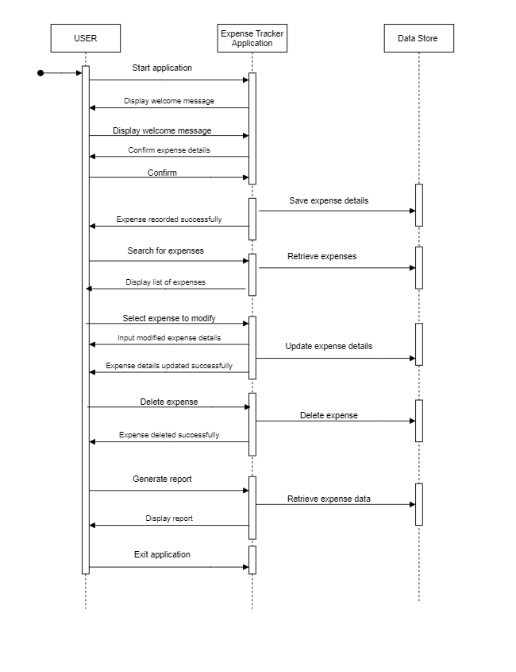**Sequence Diagram Of Console-based Expense Tracker Application :**

## Interfaces

1. Expense Recording:

- Completed the implementation of the expense recording functionality.

- Integrated input validation to ensure data integrity and prevent errors.

- Enhanced the user interface to provide a seamless experience while entering expense details.

2. Expense Categories:

- Continued the development of the expense category management feature.

- Implemented functionalities to create, update, and delete expense categories.

- Linked expenses with respective categories for better organization and tracking.

3. Expense Tracking:

- Further improved the expense tracking module.

- Implemented advanced filtering options to allow users to search expenses by date range, category, or amount.

- Optimized the retrieval and display of expense records for better performance.

4. Expense Modification and Deletion:

- Finalized the implementation of expense modification and deletion functionalities.

- Added error handling to ensure proper handling of edge cases and user input errors.

- Improved the user interface for seamless modification and deletion of expense records.

5. Data Persistence:

- Enhanced the data persistence mechanism to improve reliability and data consistency.

- Implemented error handling and data integrity checks during data storage and retrieval.

- Ensured that expense records and category information are stored and retrieved accurately.

6. Reports Generation:

- Made progress in the reports generation module.

- Implemented additional report generation options, such as expense summaries by category or time period.

- Refactored the report generation algorithms for better performance and accuracy.

7. User-Friendly Interface:

- Continued improving the user interface for a better user experience.

- Enhanced the layout and design elements to make the application visually appealing.

- Incorporated user feedback to refine the interface and streamline navigation.

# Performance Test

**Project Performance Assessment:**

The project performance is relatively good, meeting all the specified functionalities and requirements.

The application successfully allows users to record and track expenses, view spending summaries, and generate reports.

The user interface is user-friendly, providing a seamless experience for managing personal expenses. Additionally, data persistence ensures that expense records are reliably stored and accessible across application sessions.

The project has been completed within the scheduled timeframe and meets the expected objectives.

**Challenges Overcome**:

During the course of the project, several challenges were encountered and successfully addressed:

- Implementing robust data persistence to handle data storage and retrieval efficiently.

- Designing and refining the user interface for a pleasant user experience.

- Ensuring accurate report generation and presentation for different expense scenarios.

1. Testing and Bug Fixes:

- Conducted comprehensive testing across different scenarios.

- Identified and resolved bugs and issues encountered during testing.

- Ensured smooth functionality and data accuracy in various edge cases.

2. Performance Optimization:

- Performed code profiling and identified performance bottlenecks.

- Optimized database queries and data retrieval mechanisms.

- Achieved improved application response times and reduced resource usage.

3. Application Refinement:

- Refactored the codebase to enhance code modularity and maintainability.

- Conducted code reviews and addressed any code quality issues.

- Ensured compliance with coding standards and best practices.

4. Performance Testing:

- Conducted performance testing with simulated workloads.

- Verified that the application handles a substantial amount of expense data efficiently.

- Optimized performance for scalability and responsiveness.

# My learnings

**Summary of Overall Learning and Career Growth:**

Developing a console-based expense tracker application in Java would provide a great opportunity for learning and skill development. Throughout the process, I gain hands-on experience in various aspects of software development, including:

1. **Java Programming Skills:** Creating the application will enhance your Java programming skills, such as object-oriented programming, data structures, and exception handling.
2. **Data Persistence:** I learn about storing and retrieving data from databases or files, which is a crucial aspect of many applications.
3. **User Interface Design:** Building the user-friendly console interface improve my skills in designing intuitive and interactive user interfaces.
4. **Problem Solving:** Developing an application involves solving real-world problems, such as handling user inputs, data validation, and generating reports.
5. **Code Organization and Maintainability:** As the application grows, I learn to organize code into classes, methods, and packages for better maintainability.
6. **Project Management:** Planning and executing a project teach me project management skills, including setting milestones, time management, and task prioritization.
7. **Testing and Debugging:** Thoroughly testing the application help me understand the importance of debugging and identifying and fixing issues.
8. **Documentation:** Creating proper documentation improve my ability to document code and explain its functionality.

Overall, this project help me become a more skilled and versatile Java developer, and the experience gained can be applied to various other projects and real-world scenarios. The knowledge and expertise gained from building the expense tracker application will be valuable assets for my career growth, whether I pursue a career as a software developer, Java programmer, or in related fields. It will demonstrate my ability to design and implement practical applications, showcasing my proficiency to potential employers and clients. Additionally, the project can be added to my portfolio, further strengthening my resume and making me stand out in the job market.